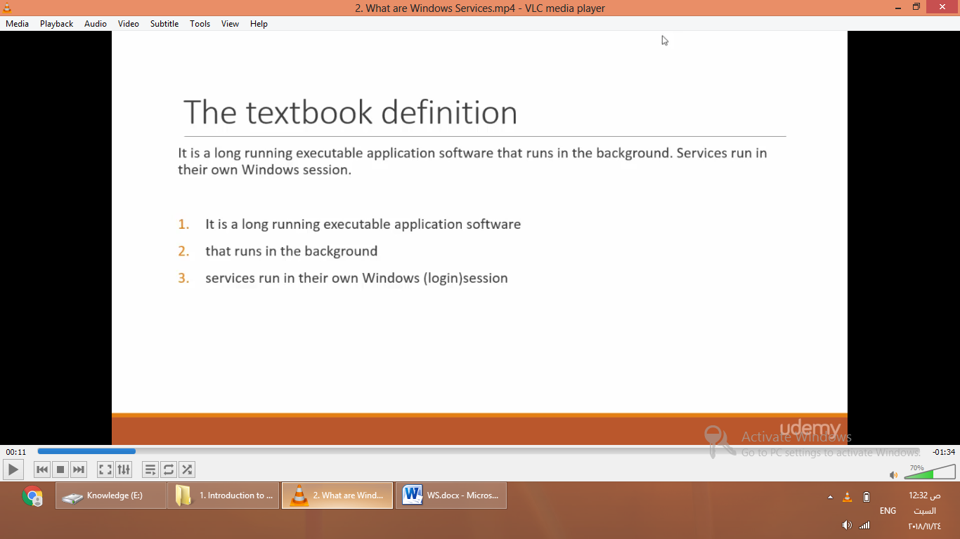



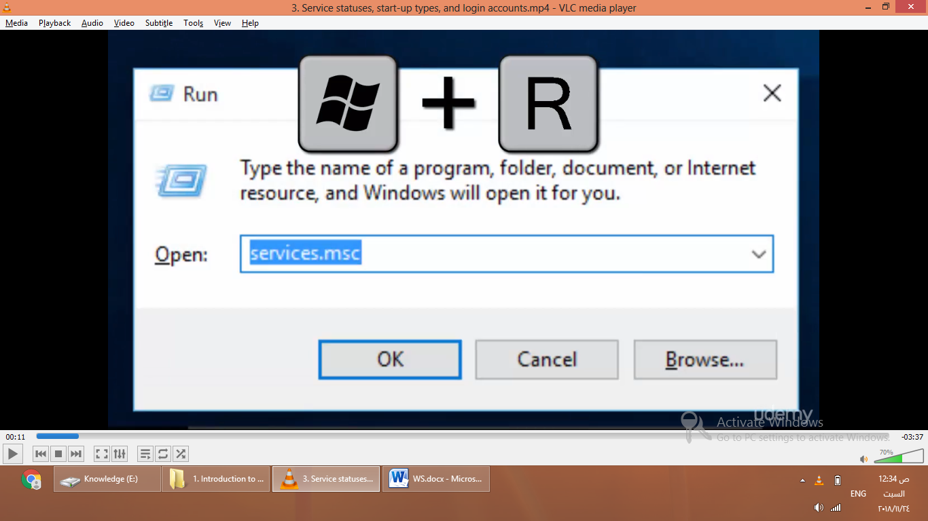

Status

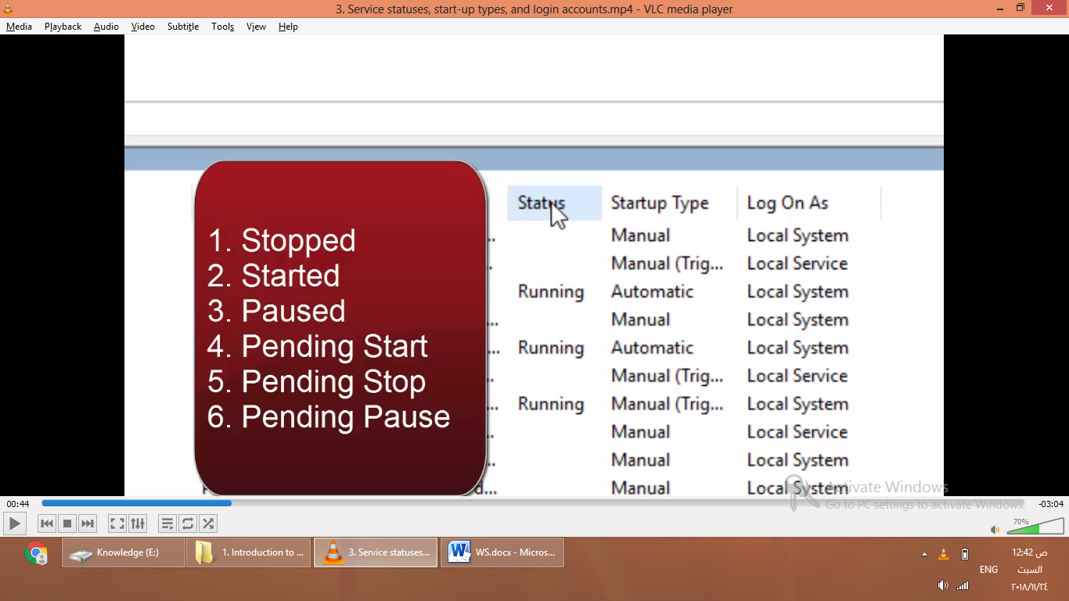

Start up type

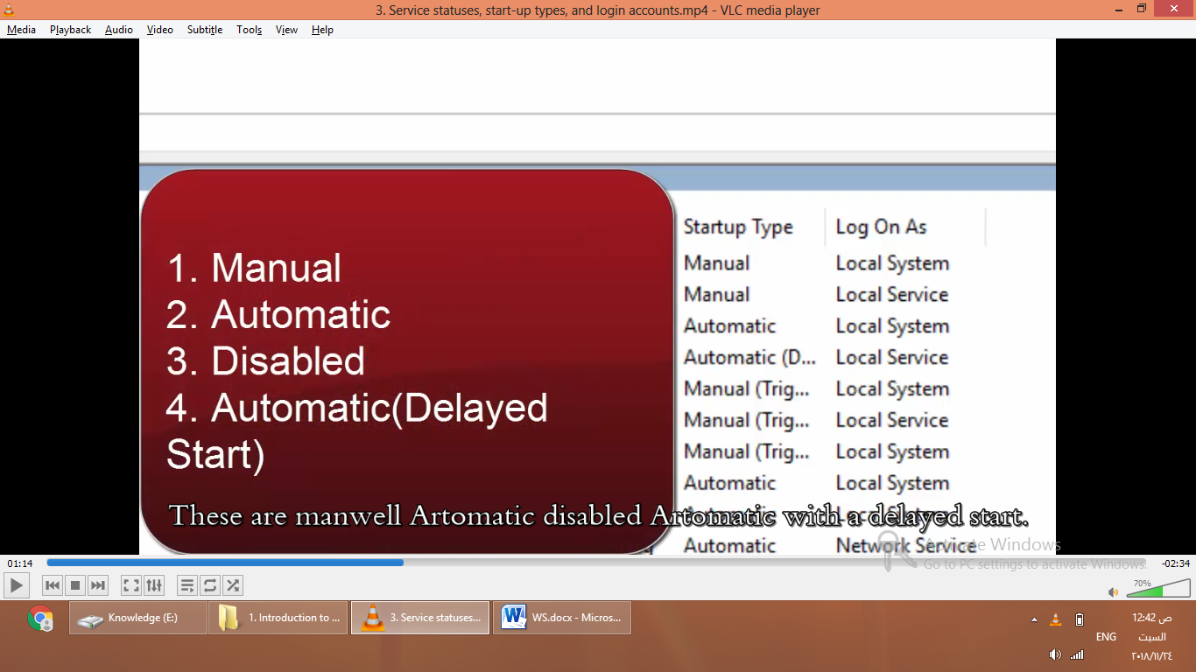

The account associated with service

;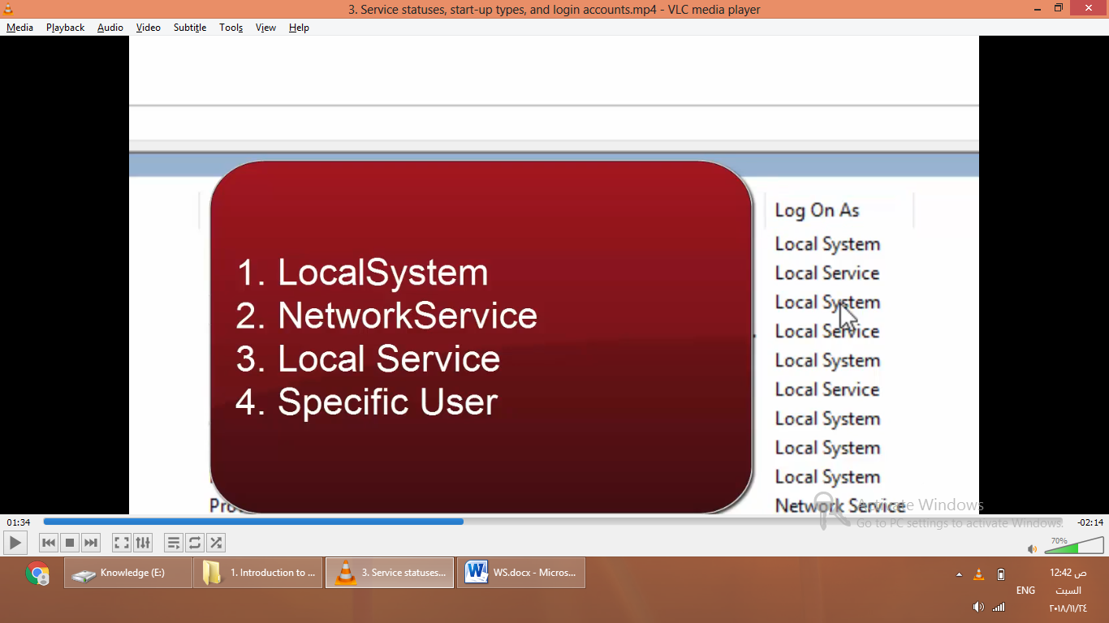

Console Application Vs Windows Service:

1. Cann’t directly debug a WS ,Place a break point within it ,use exe to run
2. You simply want to install it ,or you have this msg
3. 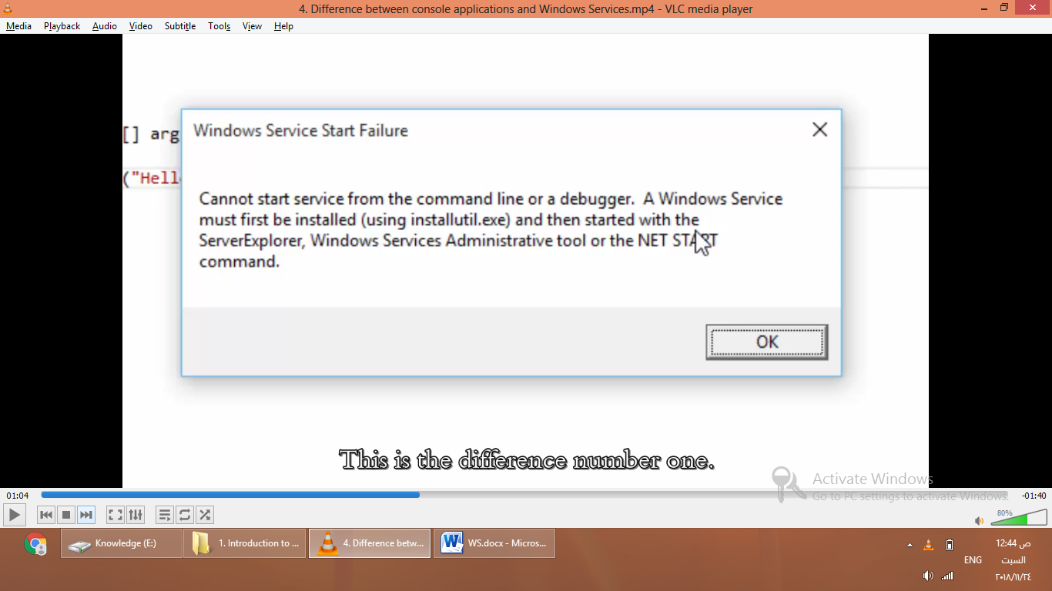

Create a New WS Project

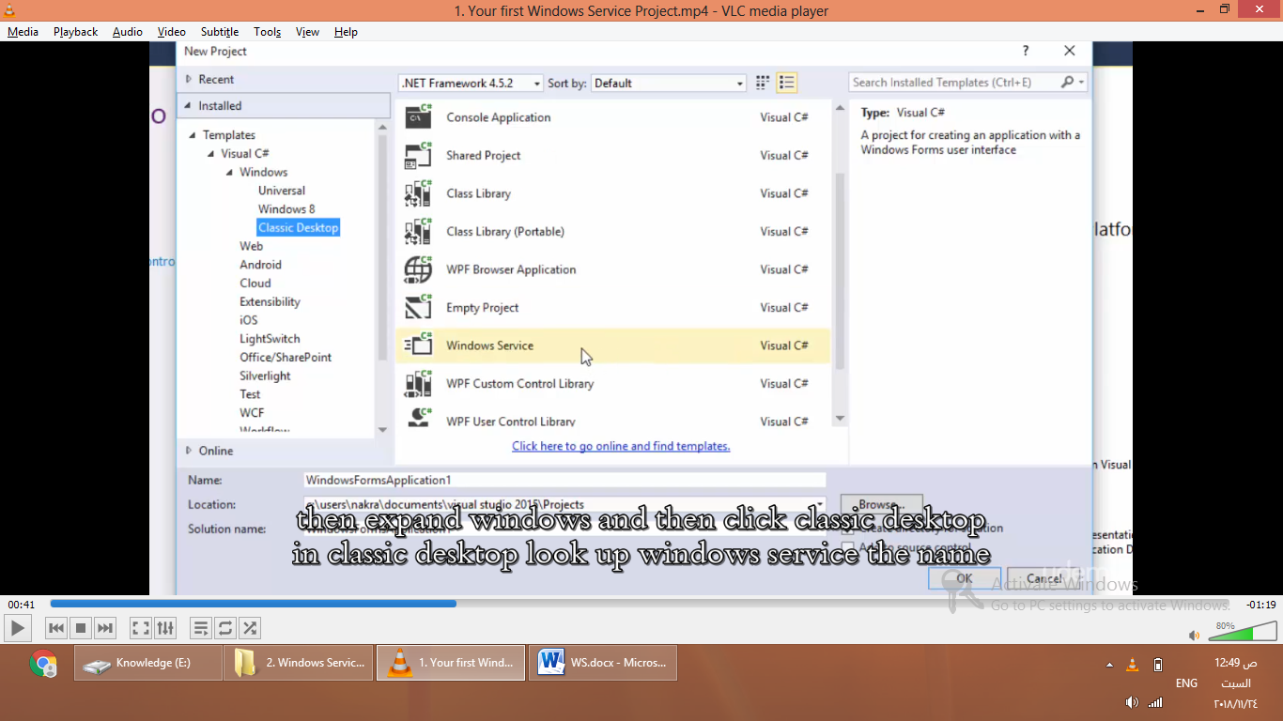

Rename

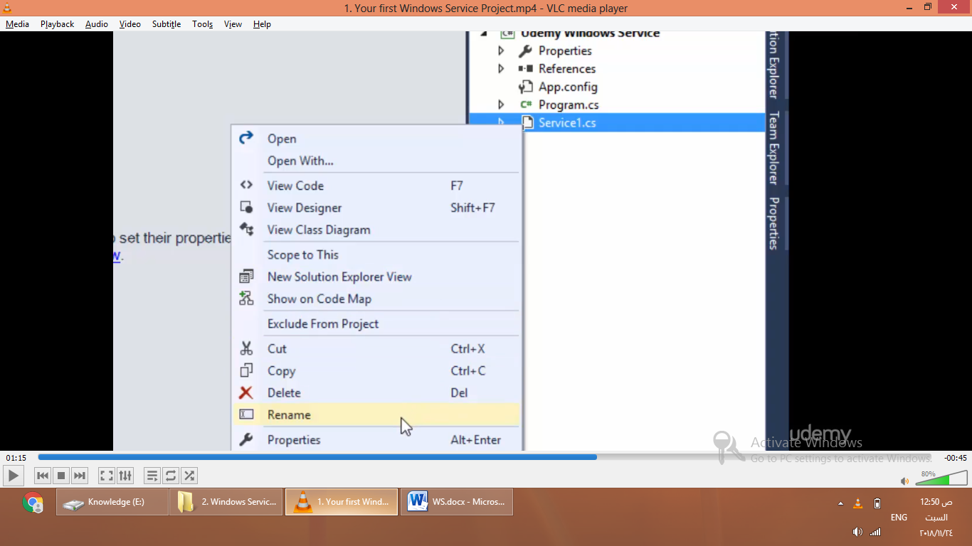

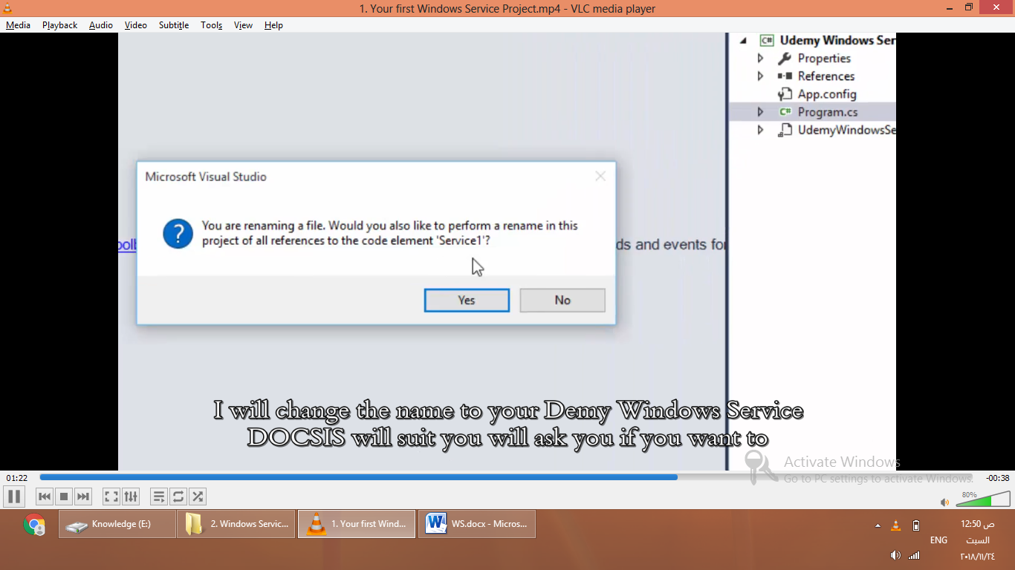

Say yes. ,leave program.cs as it’ s name ,build solution.

You want to install a WS before running it.

Open designer mode : view => designer

Add installer

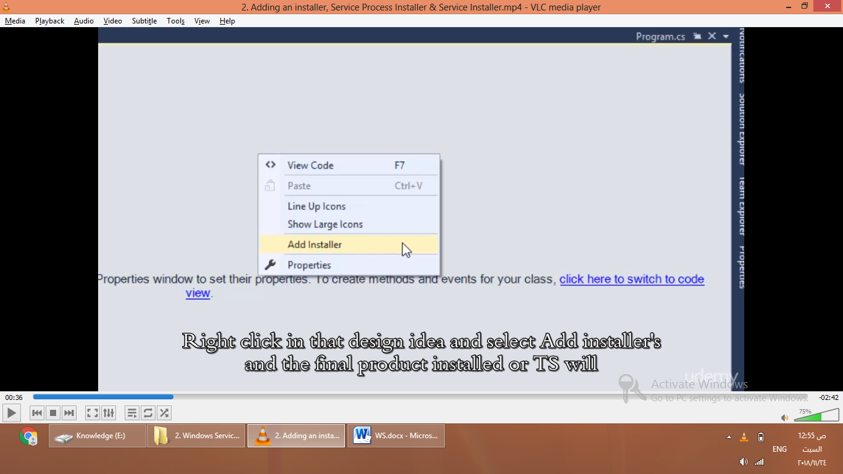

Will look like this

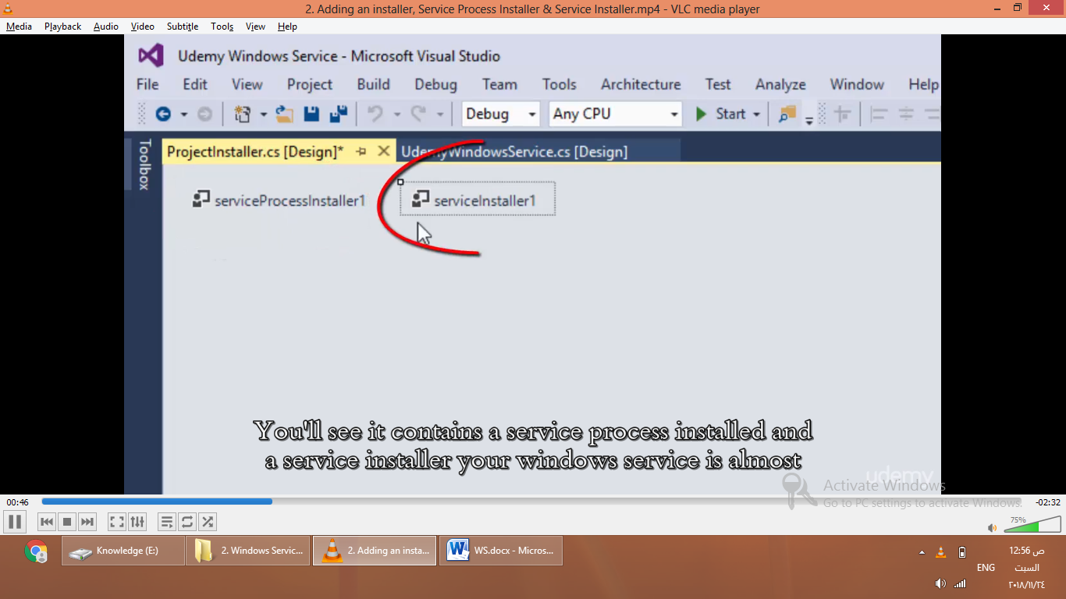

Choose properties of service proccess installer

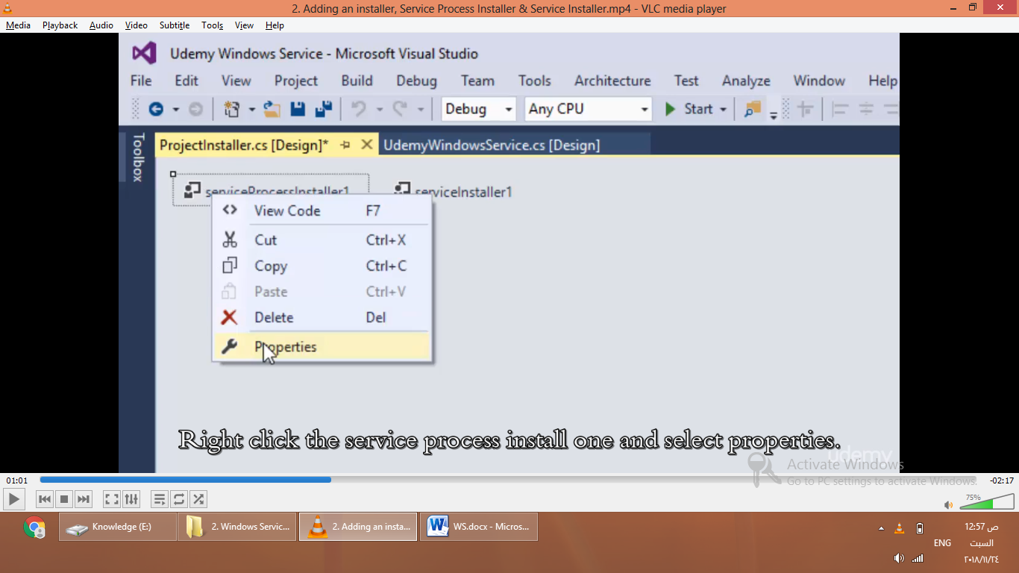

The log on account used by Ws to log on to windows.

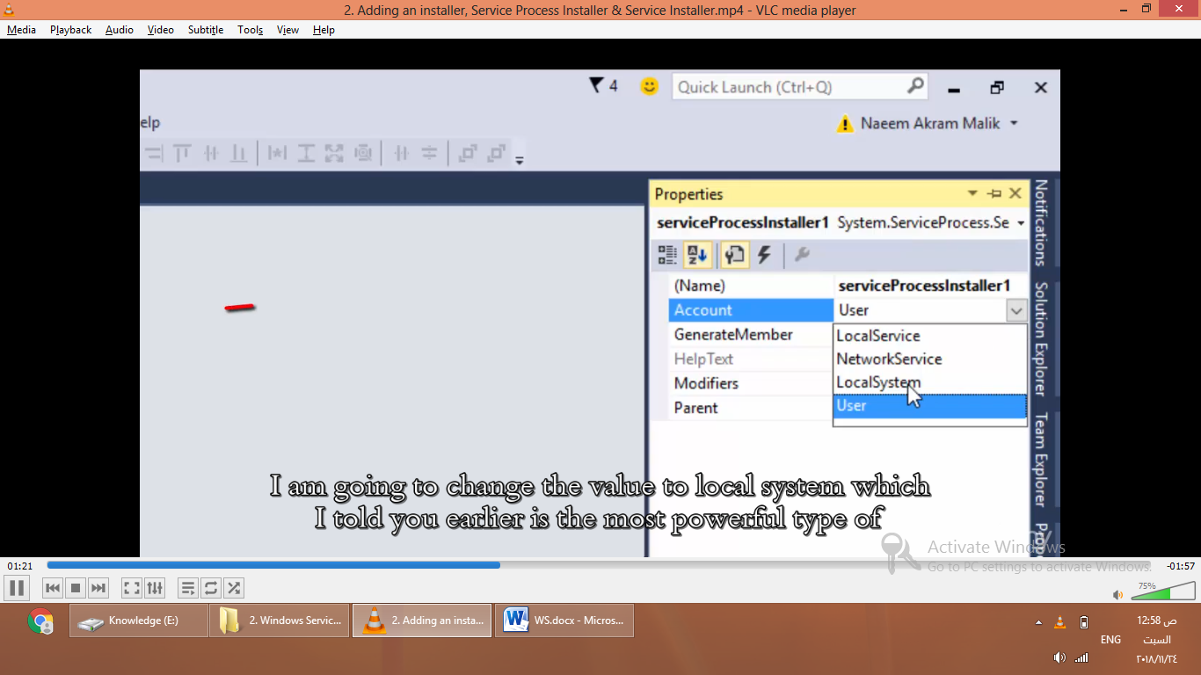

Set it to local system

Choose service installer properties

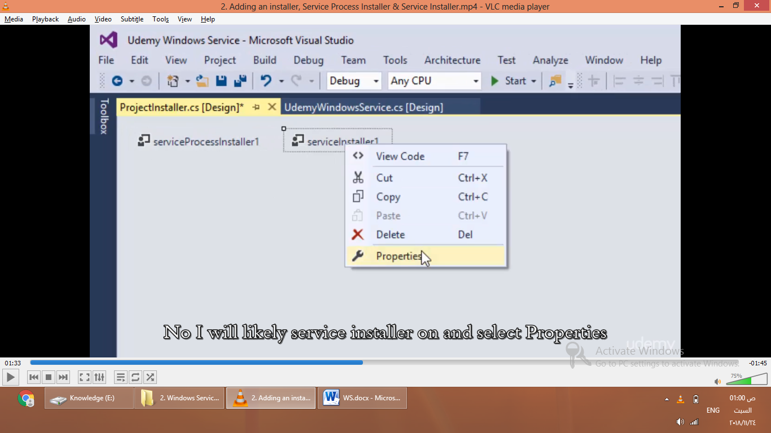

Change display name and description

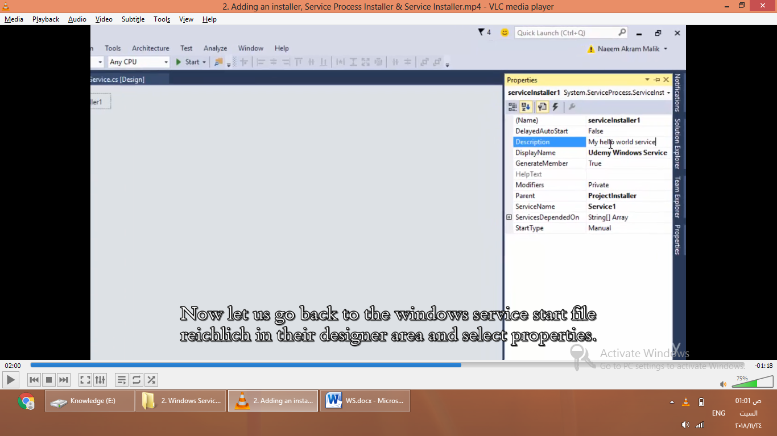

Go to WS.cs designer area ,choose properties

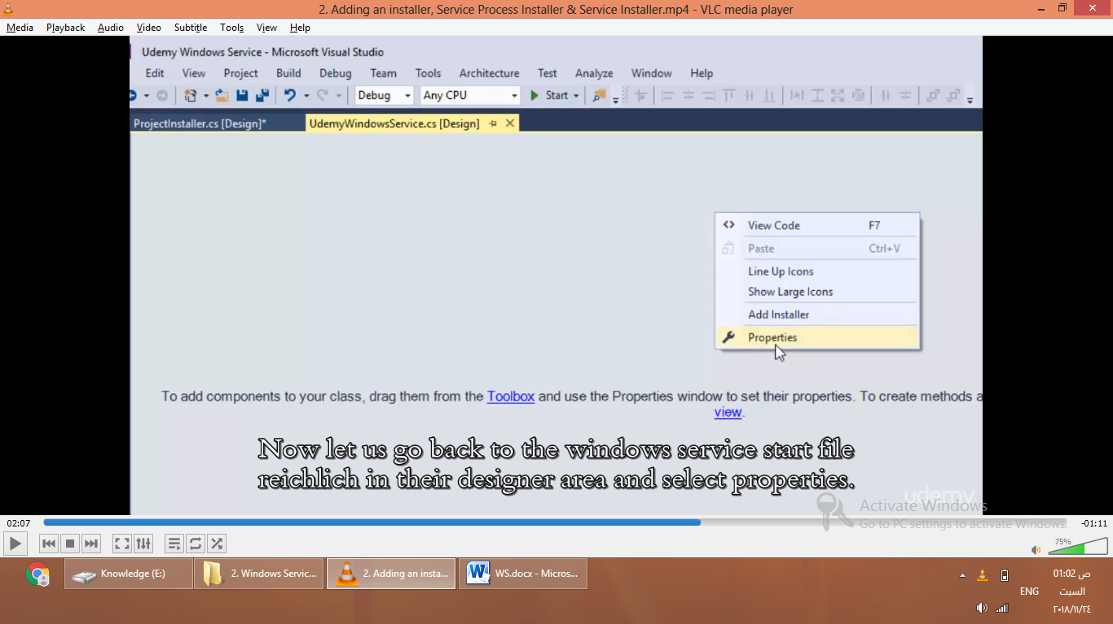

udemyWindowsService .ServiceName must equal Servicenstaller.ServiceName

now change

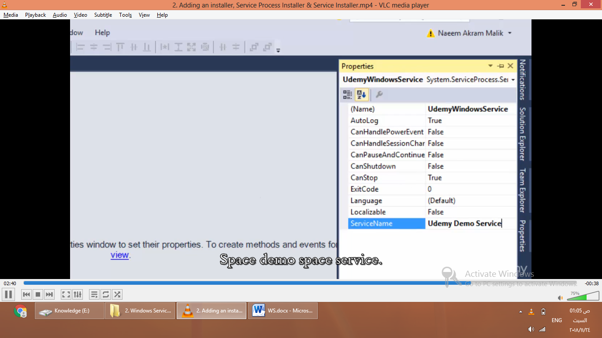

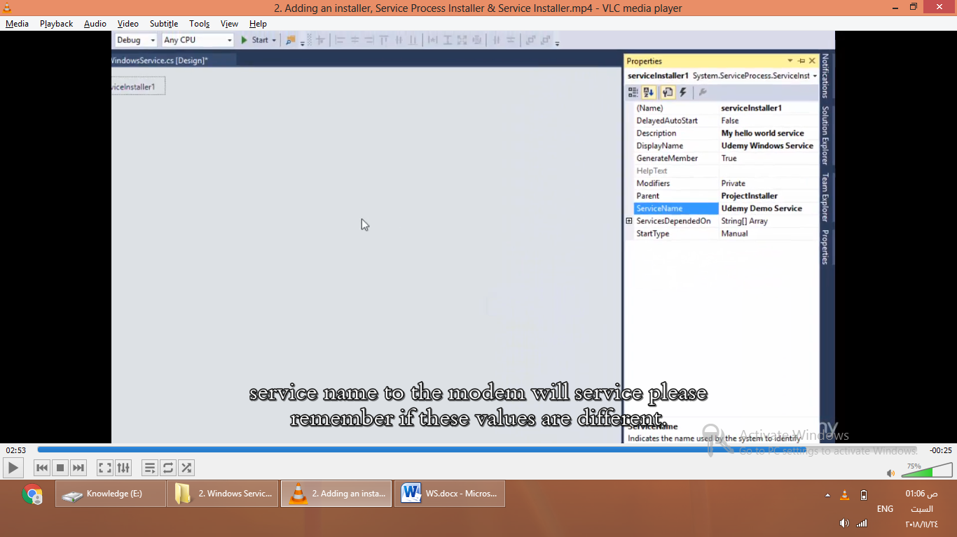

Open UdemyWindowsSerive -> view code



onStart method is called when service is started

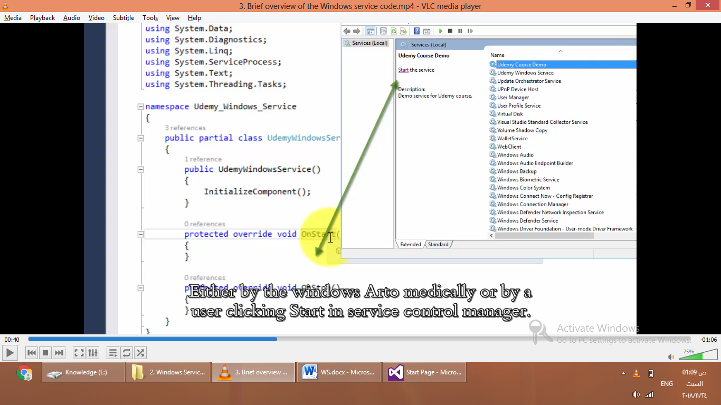

Write some code

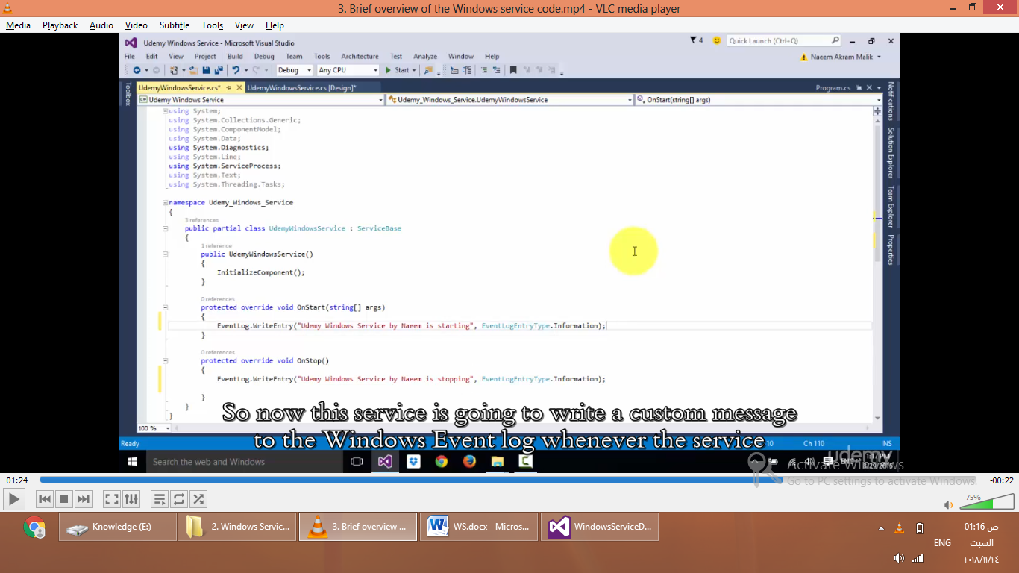

protected override void OnStart(string[] args)

{

EventLog.WriteEntry("Hello World,udemy Windows Service Started",EventLogEntryType.Information);

}

protected override void OnStop()

{

EventLog.WriteEntry("Hello World,udemy Windows Service Stopped", EventLogEntryType.Information);

}

Show all files

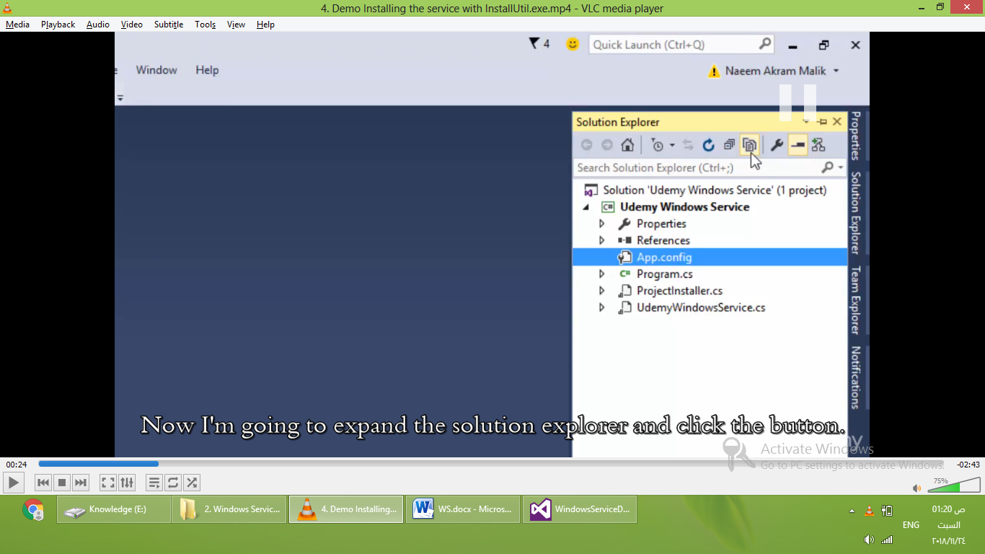

Choose bin -> Debug->right click -> show in file explorer

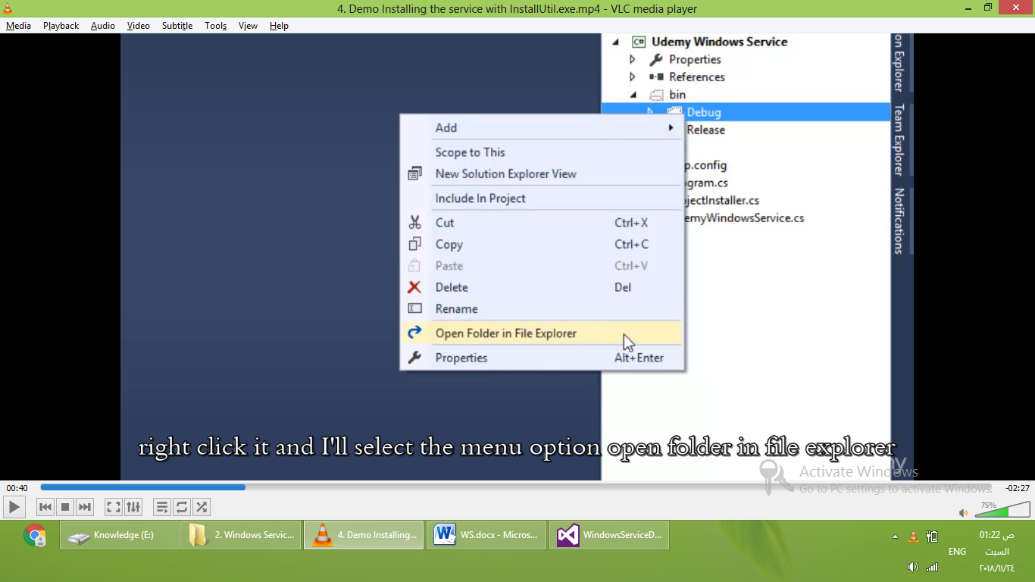

open windows menu,search for developer command prompt for VS2015,run as admin

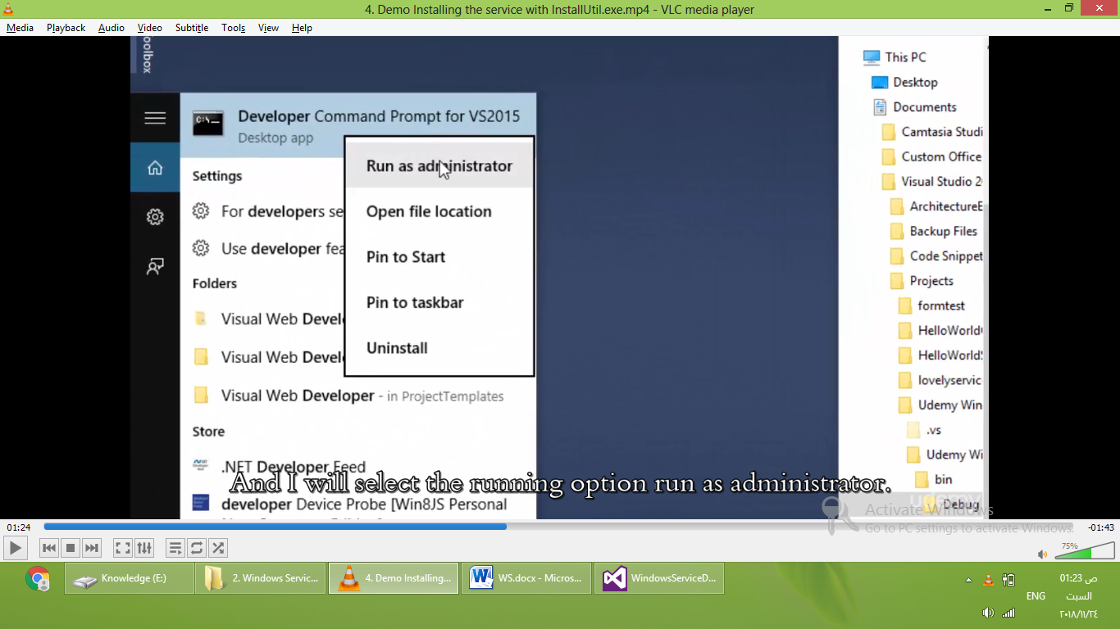

Shift + right click on ws.exe ,copy as path

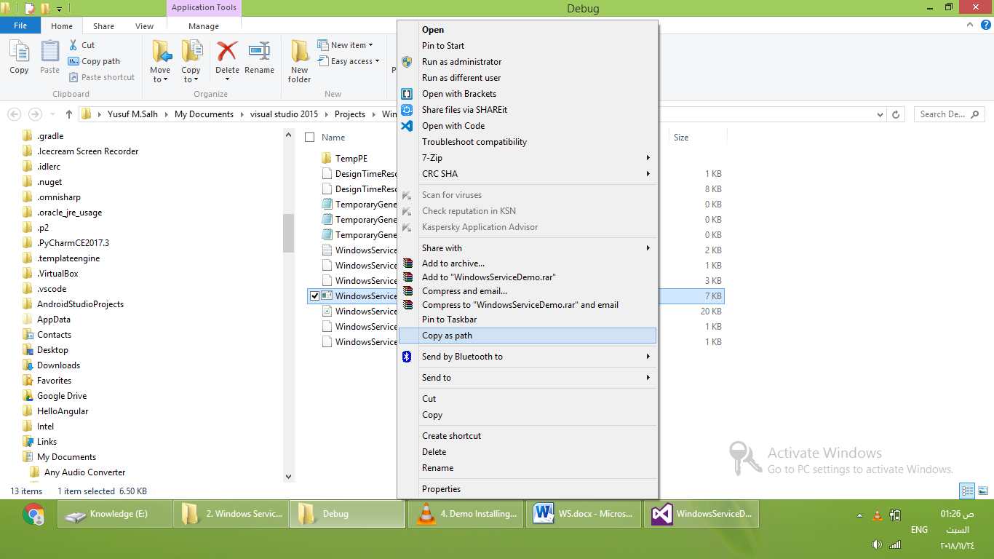

Type installutil.exe –I path of service.

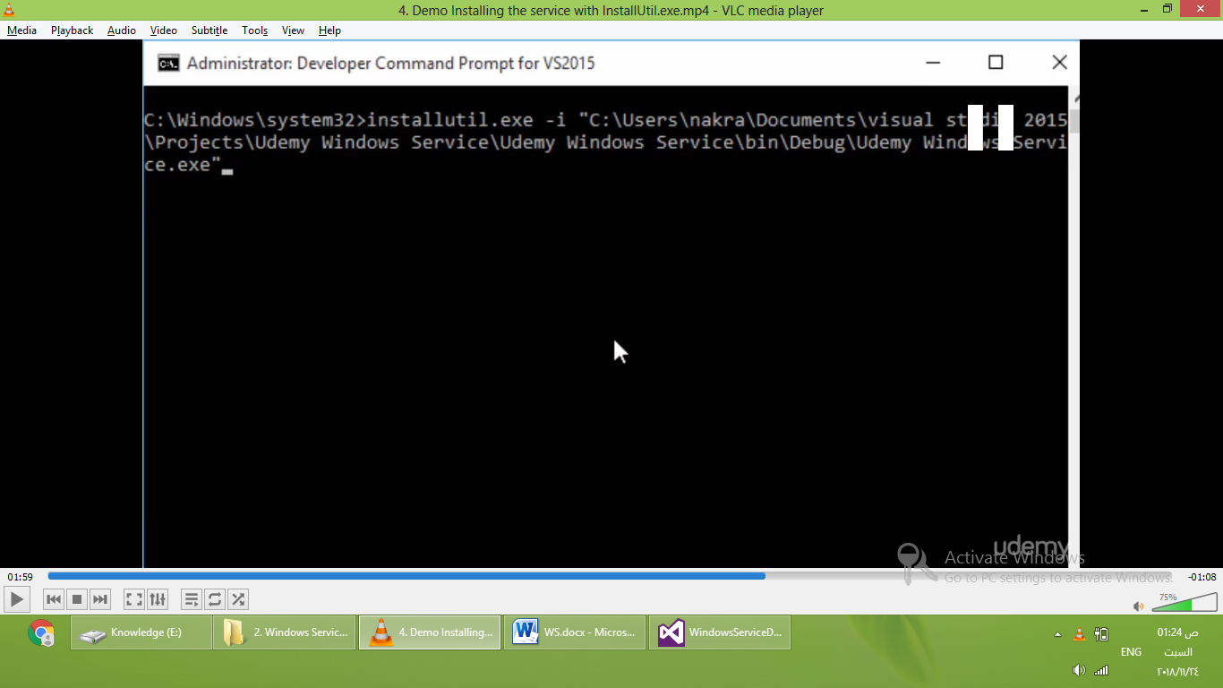

Installed successfully

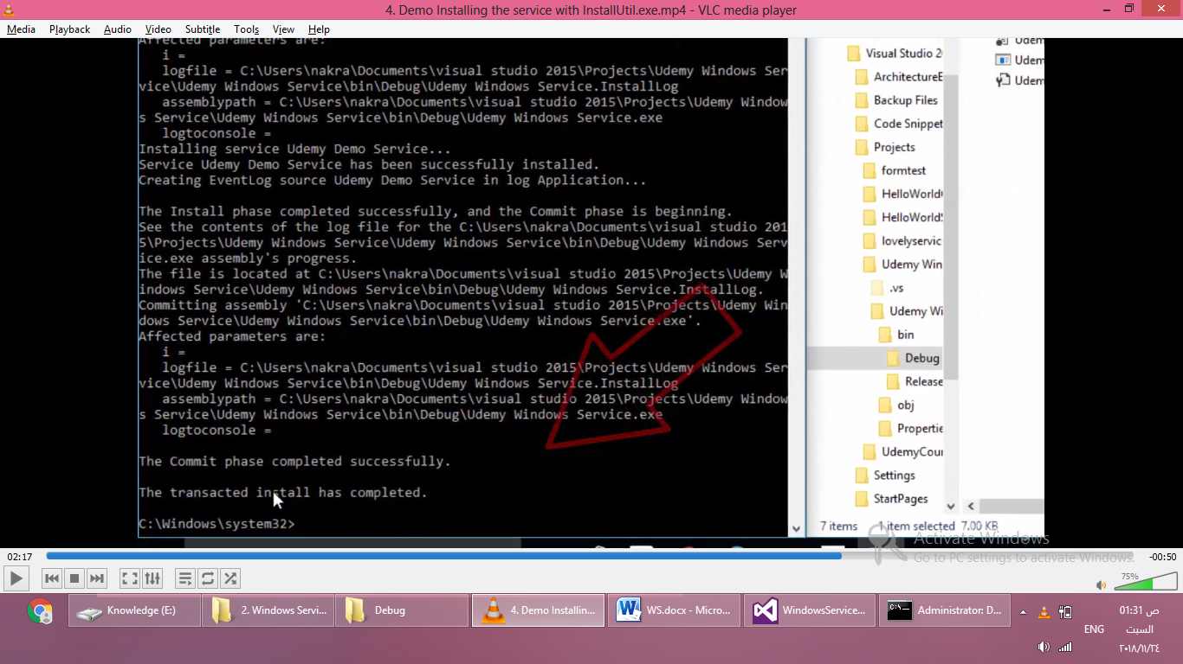

Open service controller manager

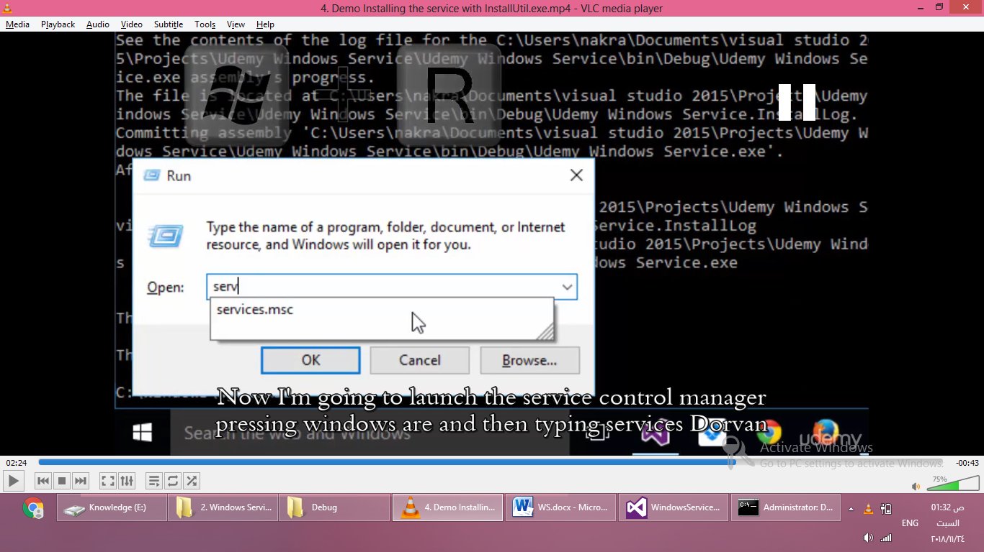

Search for your service name

v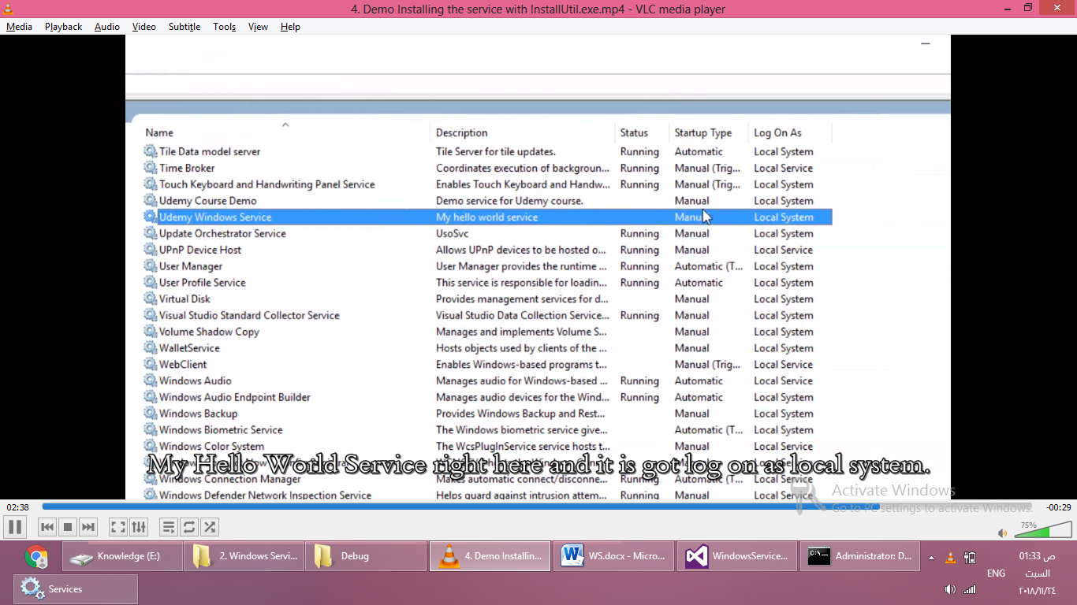

click start

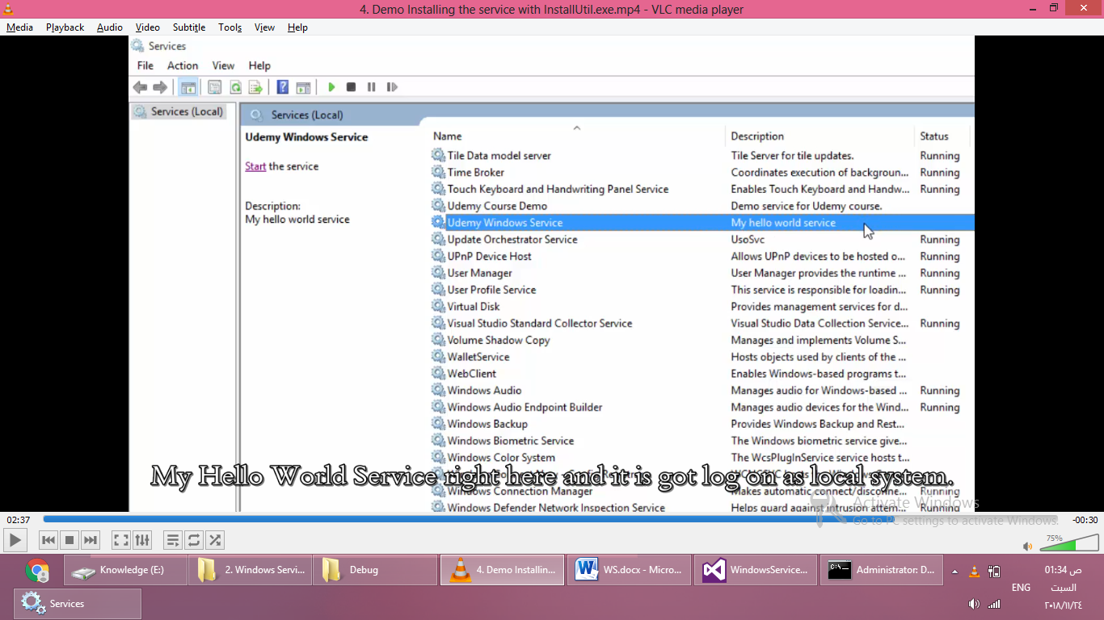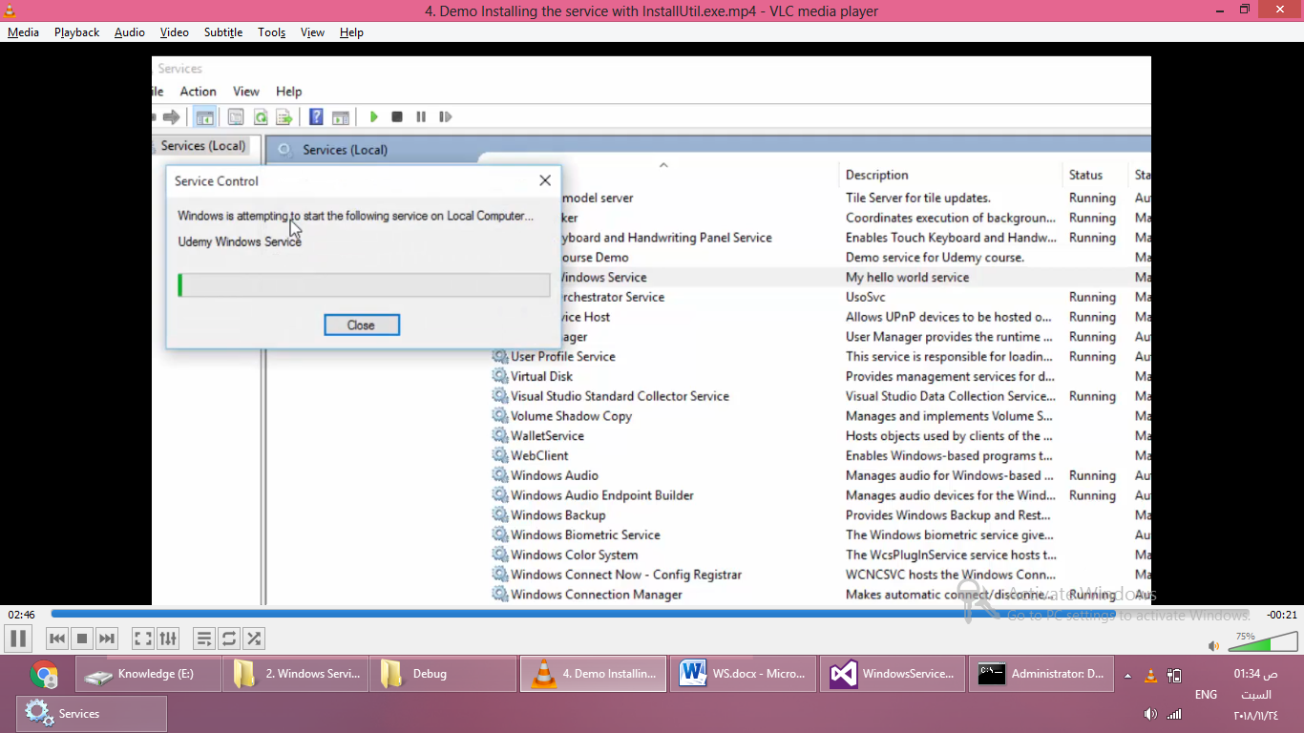

Then stop the service :D

Open the windows event viewer

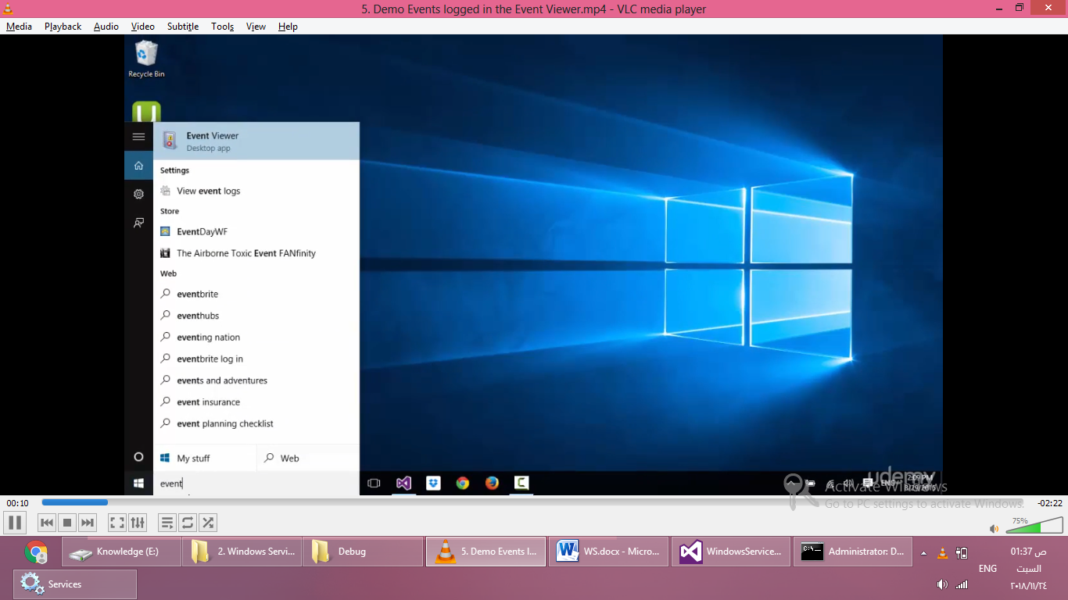

For windows 8 my computer -> windows logs -> manage

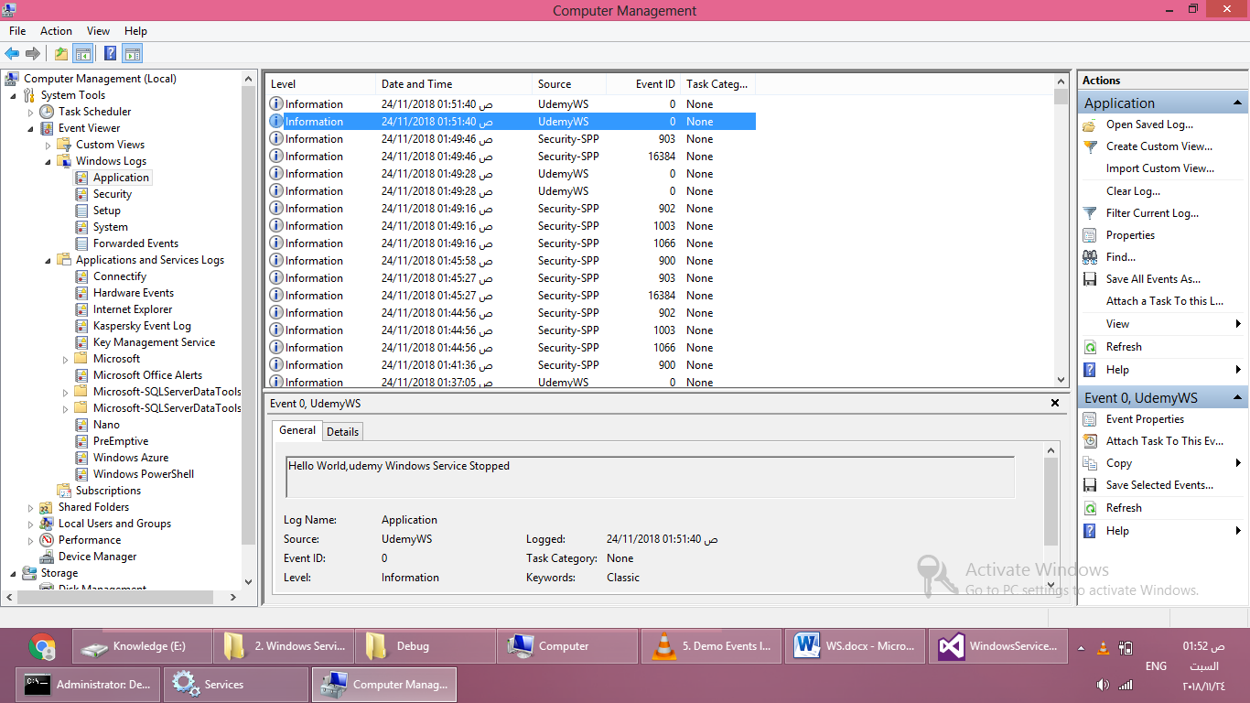

Check system tab to see details about service

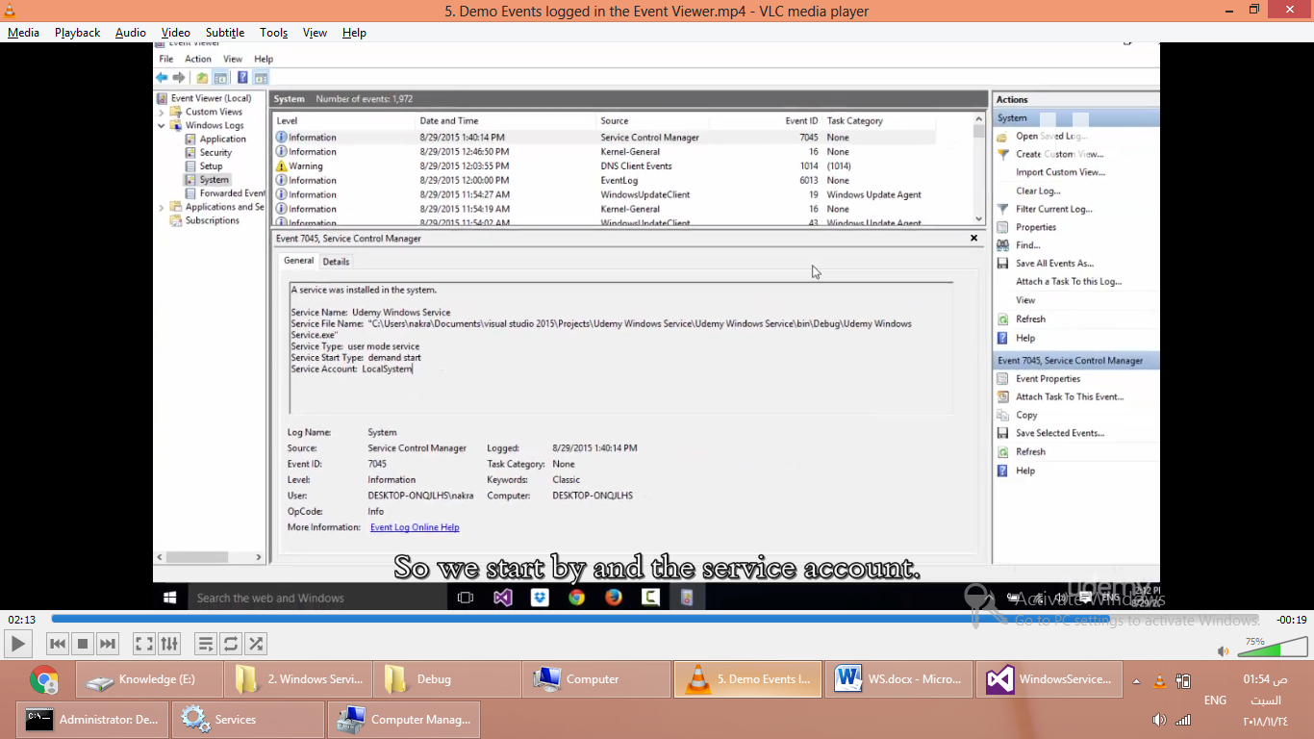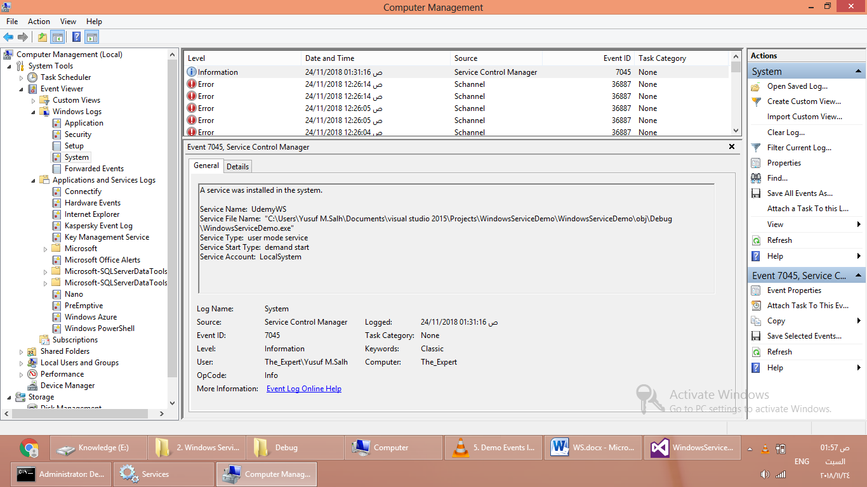

InstallUtil.exe –u UdemyWindowsService.exe

Start chap 3 how to debug